Policies and Analytics

Policies
A policy extends the functionality of an API and enforces certain capabilities such as security. A policy can control access and traffic without modification to the API implementation. Custom policies can provide other capabilities, such as encrypting and logging.

Policies in Mule 3
A policy extends the functionality of an API and enforces certain capabilities such as security. A policy can control access and traffic. For example, a policy can generally control authentication, access, allotted consumption, and service level access (SLA). You can apply policies to these types of APIs:
- An APIkit project. For example, deploy the APIkit project to Anypoint Platform using API Autodiscovery and apply a policy
- An API running on CloudHub. Design an API on Anypoint Platform, configure a proxy for Cloudhub, and apply a policy.
- An API deployed to a private or cloud-based Mule Runtime 3.8.x or later.
- An API deployed to API Gateway Runtime 2.x
API Manager provides a number of policies. You can also build custom policies. You deploy a proxy API application and apply one or more policies to control how and when a received request is forwarded to its implementation endpoint. You can set an API alert to notify you when an API request violates a policy for SLA.
By default, a policy applies to the entire API, filtering traffic requests to every resource and method.
In Mule Runtime 3.8.0 and later, you can enhance security through policies by using Gatekeeper. Gatekeeper disables an API until all online policies are applied.
Management Architechture

Policies are implemented through coordinated communication between these components:
- API Manager
- One or more API Gateway Runtimes or Mule 3.8.0 Runtime or later
- One or more API proxy applications
In API Manager you can configure and apply policies to an API version using an Anypoint Platform account and organization.
A particular API version can also be tied to a particular API implementation endpoint, which can then auto-generate an API proxy application.
You can then deploy an API Proxy to a Mule runtime, or to a standalone API Gateway Runtime if your API implementation runs on a Mule Runtime 3.7.0 or older. Mule Runtime 3.8.0 and later already include all the API gateway capabilities embedded within the runtime.

Each API proxy application receives requests on HTTP or HTTPS URLs specified by the API. Normally requests are forwarded to the corresponding API implementation endpoint URL, and then the response travels through the API proxy application back to the requesting client application.

Policy Injection and Enforcement

When you deploy an API proxy application for a specific API version to a legacy API Gateway Runtime or to Mule Runtime 3.8.0 or later, any applied policies in the runtime /policies folder are injected into the API proxy. This changes the behavior of the application.

When the proxy application receives a new request, all injected policies are applied to decide if, and how, the request is forwarded to the API implementation endpoint.

In this way, the actual policy enforcement occurs inside the proxy application itself, minimizing the cross talk between the API proxy, which is processing the received request, the Anypoint Platform agent, and online API Manager. The API proxy application does not require any communication with the Anypoint Platform agent running in the runtime, nor does it require any communication with API Manager.

However, the Anypoint Platform agent remains connected to API Manager. After policies are reconfigured or removed from API Manager, those policies are downloaded to any connected API Gateway or Mule runtimes, which updates each runtime /policies folder. The policy changes are then again injected into each API proxy application. This allows policies to be dynamically changed without having to redeploy the API proxy application, and without having to restart the API Gateway or Mule runtimes.

Categories

You can filter the list by policy categories:
- Compliance
- Security
- Quality of Service
- Transformation
- Troubleshooting
After selecting a category, you can further filter the list by the type of protection it fulfills.

If a policy is already applied, or if the protection it provides is already fulfilled by another policy you applied, the policy appears unavailable.

Policy Categories

The following table lists the policy name, the category and the characteristic the policy fulfills.
You can only one policy of each characteristic.

Policy | Category | Fulfills | Required
Client ID Enforcement | Compliance | Client ID Required | None
CORS | Compliance | CORS-enabled | None
Header Injection | Transformation | Header Injection | None
Header Removal | Transformation | Header Removal | None
HTTP Basic Authentication | Security | Authentication | Security Manager
IP Blacklist | Security | IP Filtered | None
IP Whitelist | Security | IP Filtered | None
JSON Threat Protection | Security | JSON Threat Protected | None
LDAP Security Manager | Security | Security Manager | None
Message Logging | Troubleshooting | Message Logging | None
OAuth 2.0 Access Token Enforcement Using External Provider Policy | Security | OAuth 2.0 protected | None
OpenAM Access Token Enforcement | Security | OAuth 2.0 Protected | None
PingFederate Access Token Enforcement | Security | OAuth 2.0 Protected | None
Rate Limiting | Quality of Service | Rate Limited | None
Rate Limiting, SLA-Based | Quality of Service | Rate Limited, Client ID required | None
Simple Security Manager | Security | Security Manager | None
Throttling -SLA-Based | Quality of Service | Throttled, Rate Limited, Client ID required | None
Throttling | Quality of Service | Throttled, Rate Limited | None
XML Threat Protection | Security | XML Threat Protected | None

Applying and Removing Policies

After setting an API URL for an API version, you can use controls in Applications, Policies, and SLA Tiers. When you click Apply New Policy, a list of MuleSoft-provided policies and any custom policies added by your organization appears.

An unavailable Apply indicates one of the following conditions:

- Another applied policy fulfills the requirement.
- Another policy is required before applying this policy.

1. Available Policies list after clicking on “Add New Policy”.

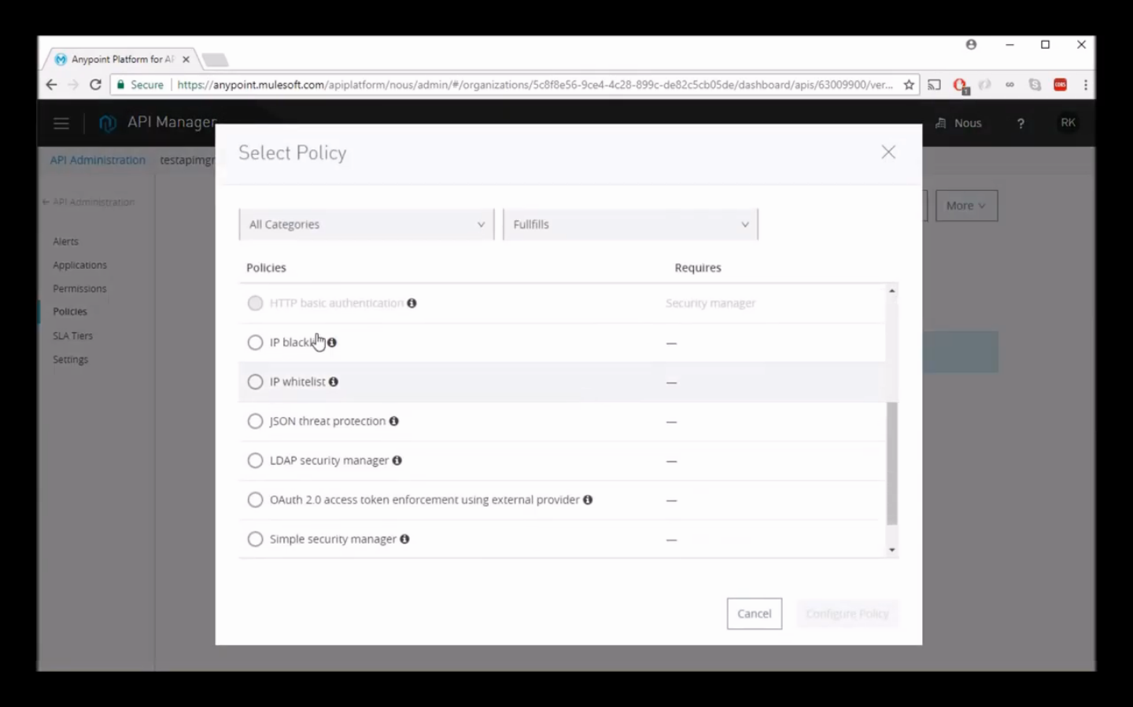

2. Applying “Simple Security Manager” policy.

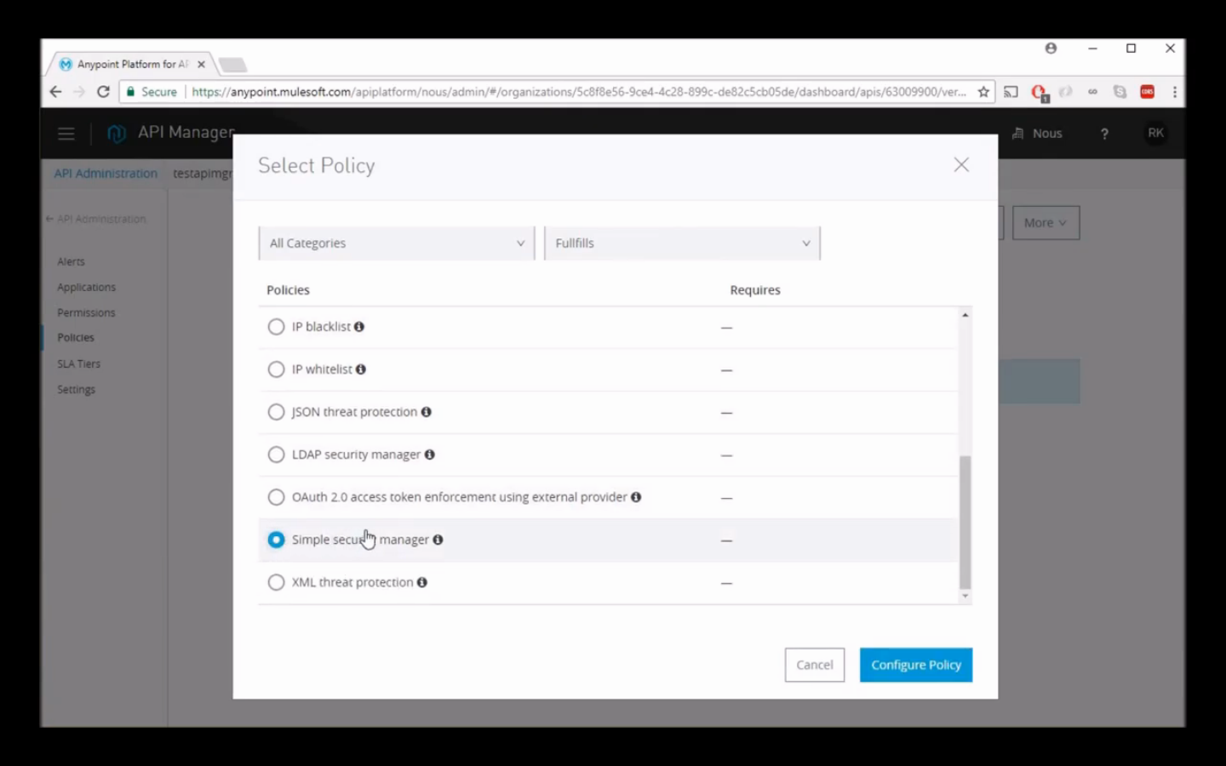

3. Setting user name and password for authentication.

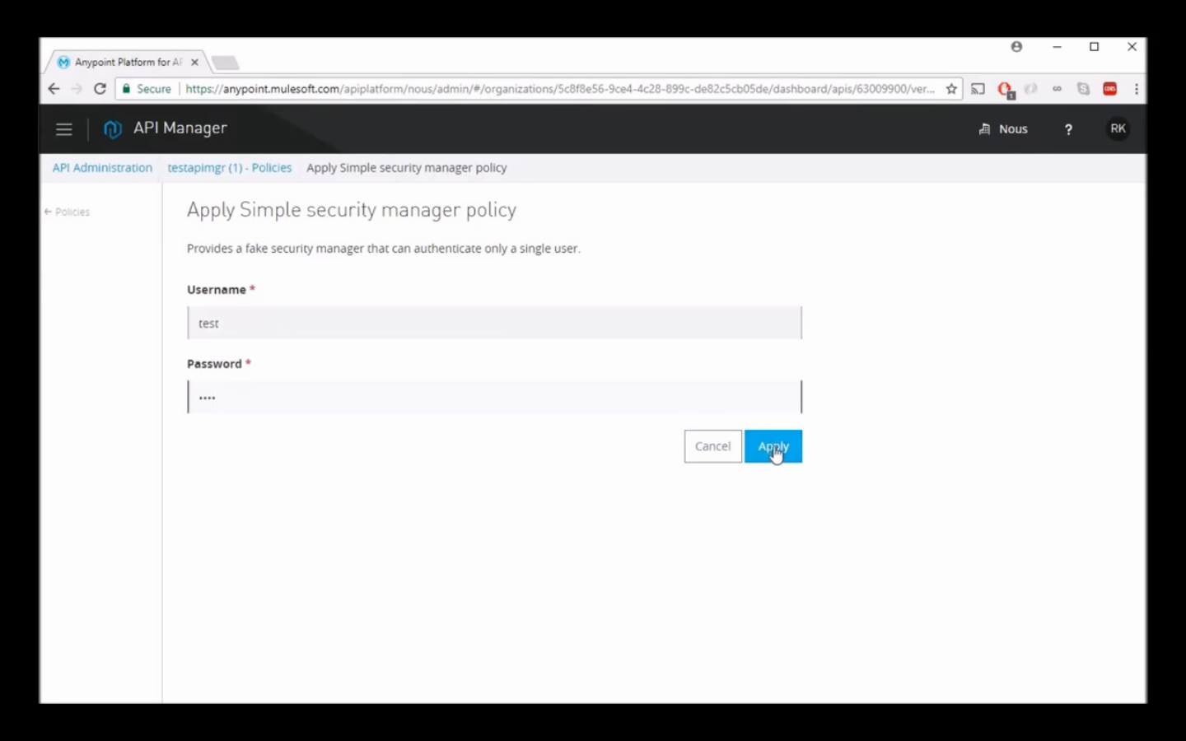

4. API asking for user name and password while hitting.
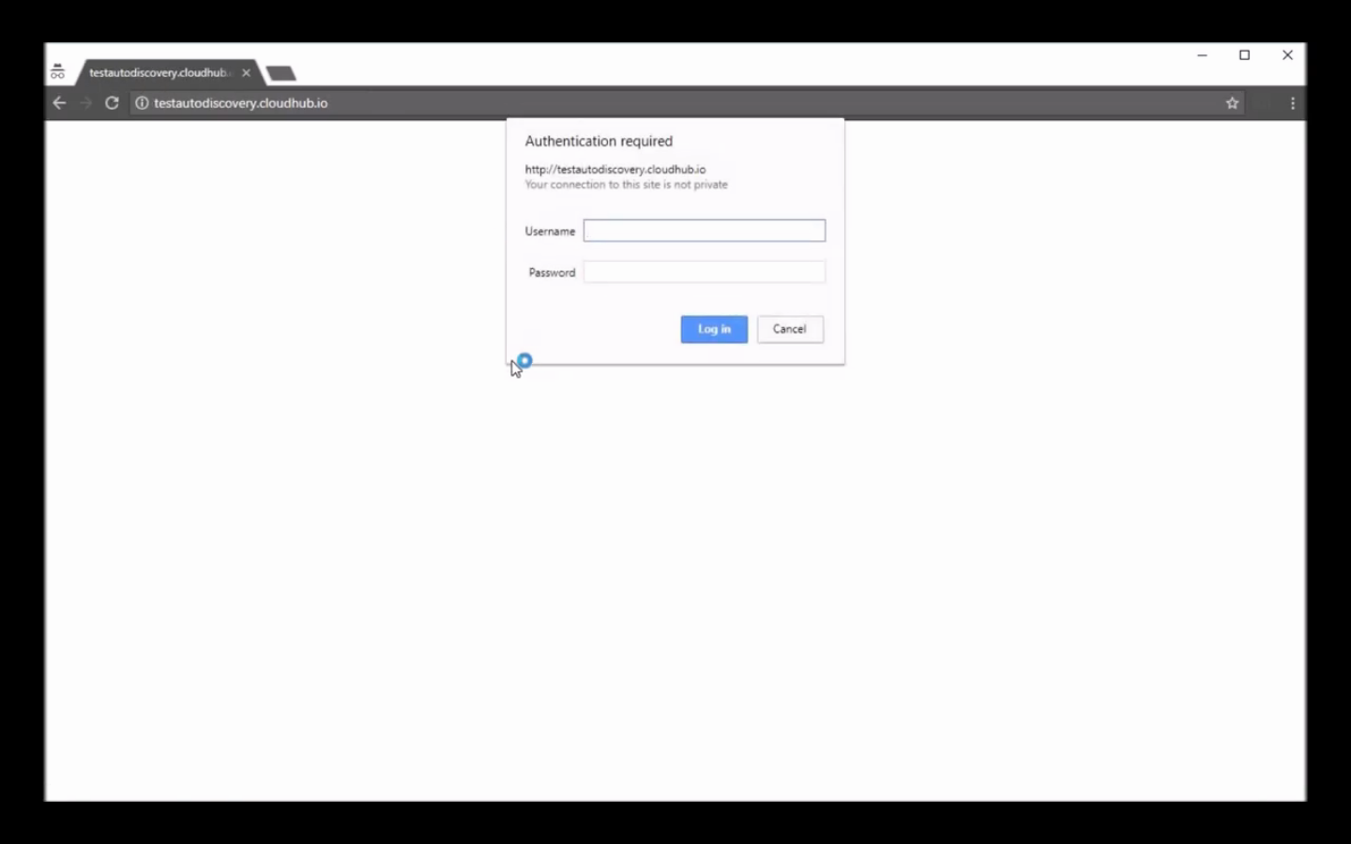

Setting the API URL

On the API version details page, you can configure the inbound endpoint of the API you plan to deploy. This action is required for Anypoint Platform to manage the API, either directly or by proxy. Defining a value in the RAML for the baseURI configures the Implementation URL of the API endpoint configuration Configure Endpoint.
- In API Manager, in API Administration, click an API version link.
- On the API version details page, click Configure Endpoint.
- Provide the actual inbound URL of the API, not a placeholder URL. If the API is deployed on-premises and you are using a load balancer, enter your load balancer endpoint here.
- Configure or accept other settings to set up and deploy an API proxy.
- Click Configure.

Re-ordering Policies

This procedure describes how to re-order policies provided by Anypoint Platform other than CORS, Throttling, and Rate Limiting policies. These policies have the highest precedence. If you apply these policies, you cannot set other policies at a higher level.

You can set the order of execution of policies for a custom policy by configuring the policy tag or the before or after blocks.

- In Anypoint Platform, click API Manager, and in API Administration, click the API version.
- On the API version details page, choose Policies.
- In the top of the list of any applied policies, click Edit Policy Order to change the priority.
- In Reorder Applied Policies, use the up and down arrows to rearrange the order of policies.
For example, if you apply rate limiting, IP whitelist, and XML threat protection, you can reorder only the IP whitelist and XML threat protection policies because rate limiting takes precedence over the other policies.
- Click Apply order.

Resource Level Policies

Using Mule 3.8.1 and later, you can apply one or more provided policies to the resource and method levels of an API that meets the following conditions:

- The API has a RAML endpoint.
- You create the API using APIkit or a RAML proxy.
Using APIkit, you can create a RAML-based API and configure a Basic Endpoint, or you create the RAML-based API and configure the Endpoint with a Proxy in the case of an existing API.

A policy applied at a resource level affects all methods, or selected methods, within the resource.
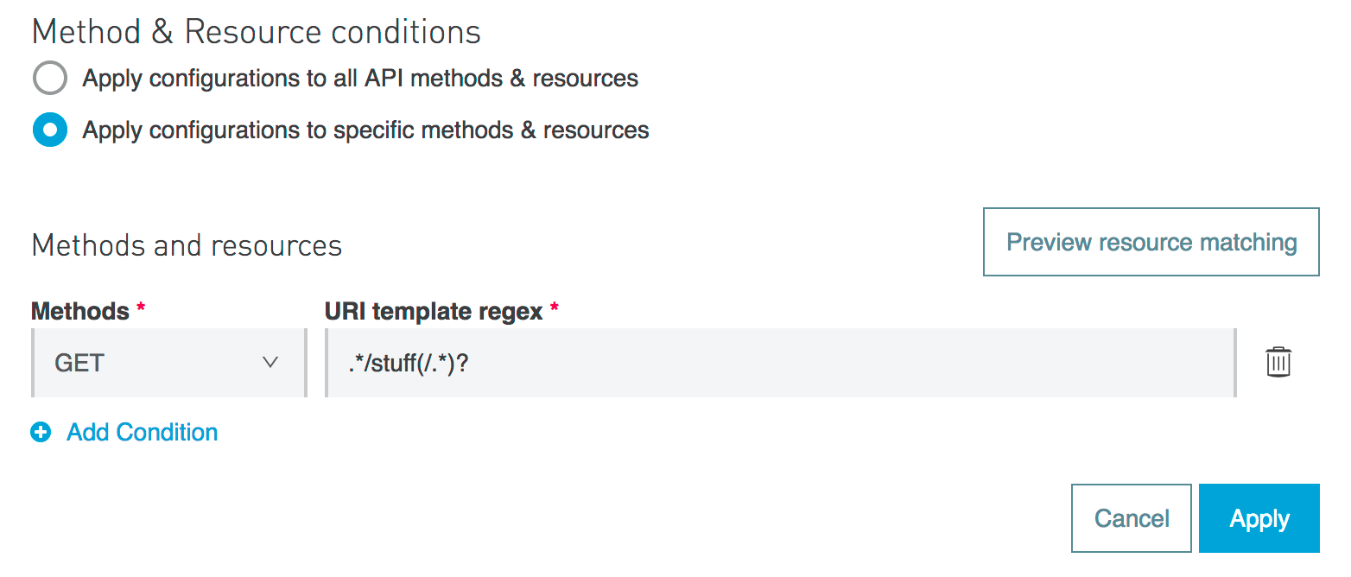

You need to add some code to existing custom policies to support this capability.

You can apply multiple conditions to filter your resources and methods. The URI template regex can be applied to one, many or all the methods that your API has.

Unsupported Policies

You cannot apply the following policies to resources:
- Cross-Origin Resource Sharing
- LDAP Security Manager
- Simple Security Manager

Usage Scenarios

The uses for resource level policies are limited mainly by your imagination. Here are a few possibilities:

- Applying policies to specific resources
- Securing a subset of an API
- Setting different limits on resources

Applying a Resource Level Policy

The simulation of the example API looks like this:

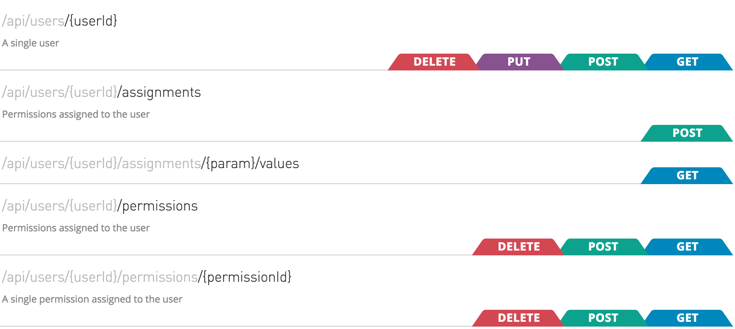

A resource level policy supports Java regular expressions. For example, you can use the wildcard to apply a policy to multiple resources. When you apply the policy to the API, specify the resources to which it applies.

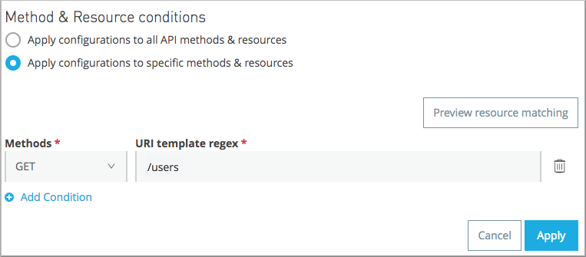

You can apply multiple conditions to filter your resources and methods. The URI template regex can be applied to one, many, or all the methods that your API has.

Do not use a placeholder, such as {userid}, in the regular expression. Using a placeholder in an expression fails because the placeholder does not match the actual node. In the case of the example placeholder {userid}, the node actually looks something like this:

/api/users/671962fc-f076-4b19-bc38-45ba3a4e4095/permissions/1234

- 671962fc-f076-4b19-bc38-45ba3a4e4095 is the user ID
- 1234 is the ID of a permission
To apply a policy to resource /api/users/{userid} that represents a single user and all nodes below the resource, use the following expression:

/api/users/.*

To apply a policy to only the permissions resources /api/users/{userId/permissions} and /api/users/{userid}/permissions/{permissionId}, use the following expression:

/api/users/.*/permissions.*

Securing a Subset of the API

You can add security to create, update, and delete operations, leaving read-only operations unsecured. For example, you want to apply an HTTP basic authentication policy to specific methods and resources. Select POST, PUT, PATCH and DELETE methods and use the following expression to cover every resource URI of the API:

.*

This expression enforces security on write operations, leaving GET (read-only) unsecured. Use a more specific expression to covering just a subset of the resources.

Traits & policies concepts of RAML based APIs

If your API exposes a RAML definition that users might need to reference, then the RAML definition should reliably detail every element that is expected in calls to your API. For example when applying a client ID-based policies implies that all requests coming to your API include a client ID and client Secret (by default expected as query parameters). To prevent user requests from being rejected, create a trait in the RAML root and then reference this trait in every operation of your API. The trait might look like this:

traits:
- client-id-required:
queryParameters:
client_id:
type: string
client_secret:
type: string
And then you can apply this trait in each individual operation like this:

/products:
get:
is: [client-id-required]
description: Gets a list of all the inventory products.

- Click Policies on the API dashboard.
In the list of policies, the RAML snippet link contains the RAML code you need to add to the RAML.

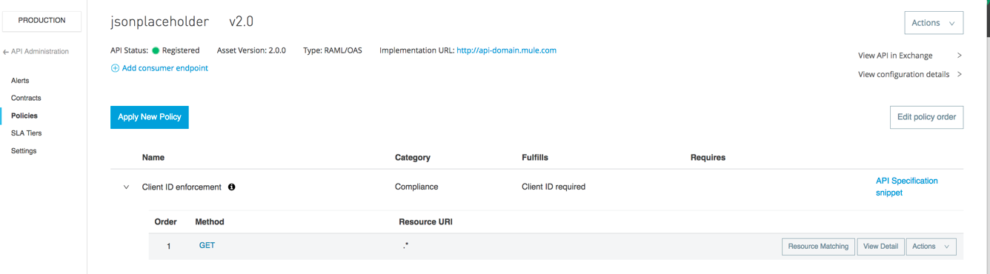
2. Click RAML Snippet.

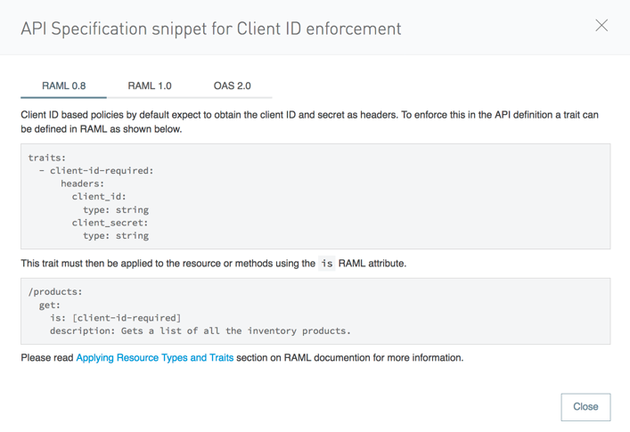

3. Select RAML 0.8 or RAML 1.0 to match the API RAML version.

4. Edit the API to add the code.

5. Redeploy the API.

Disabling, Editing, or Removing a Policy

1. In Anypoint Platform, click API Manager, and in API Administration, click the API instance.
2. On the API dashboard, choose Policies.
3. Click > to expand the policy controls for the policy you want to change.
4. Click Actions > Disable, Edit, or Remove.

Custom Policies

If you want an API policy that isn’t included in the default set of policies, you can create your own custom policy. A custom policy requires the following files:

- Policy Definition - YAML file that describes the policy and its configurable parameters
- Policy Configuration - XML file with the backend processes that implement the policy

A custom policy also must contain a pointcut declaration. See the Pointcuts Reference below for more information.

You can create a custom policy if you use one of the following runtimes:
- Mule 3.8 or later unified runtime
- API Gateway runtime 2.x or later
In Studio 6.1 and later, you can use the Studio custom policy editor (Beta).

Creating a Custom Policy

To create a custom policy, you need to be assigned to the Organization Administrators Role.

Creating the Configuration File

This procedure describes how to create a custom policy configuration file. At the end of this procedure, you can download the complete file.

- Open a new text file, and create policy, before, and pointcut elements.
- Create policy, ID, and policyName elements to track the policy for analytics.
<policy xmlns="http://www.mulesoft.org/schema/mule/policy"
id="{{policyId}}"
policyName="Regex Filter"
- Add a before section to execute on every request to the API before the actual API services are called. The after section is not needed; return results need no processing.
- Include a filter element in the before section that references an element named Expression. This filter element has a name property that matches the referenced element.
The expression parameter specifies the filtering conditions and the targeted element to filter. The YAML file defines these parameters, which are wrapped in {{curly brackets}} in the XML configuration file: {{regexFilter}} is used as the filtering condition. {{queryParamm}} is used to construct expression that references the desired query parameter.
- Include a message filter, which is a standard Mule element, to filter the incoming request. This element does not actually define the filter logic, but references the Expression element that specifies the filter’s behavior.
- Add an onUnaccepted property in the opening tag of the filter element in the before section references the policyViolation element.
...
<!-- This executes right after the inbound endpoint of the application -->
<before>
<mule:message-filter xmlns:mule="http://www.mulesoft.org/schema/mule/core" onUnaccepted="policyViolation">
<mule:filter ref="Expression"/>
</mule:message-filter>
</before>
When the criteria specified by the filter is not matched, this property calls and executes the referenced element.
7. Save the file using a .xml extension.

Creating the Definition File

In this procedure, you create a YAML file that contains the policy definition file. Next, to filter calls to the API, the policy definition includes a query parameter and a regular expression to filter the query parameter. Unmatched requests are rejected. Properties map to the elements in the UI when you apply the policy. At the end of this procedure, you can download the complete file.

- Open a new text file, and define the required properties for a policy in Anypoint Platform.
- Add the resourceLevelSupported: true property if you run Mule 3.8.1 or later. This property supports resource level policies.
id: query-param-filter
name: Query Param Filter
description: Filters query parameters
category: Security
type: custom
standalone: true
requiresConnectivity: false
resourceLevelSupported: true
providedCharacteristics: []
requiredCharacteristics: []
- Add a configuration element and two propertyName fields having the values regexFilter and queryParam.
- Add properties to define the regular expression to filter the parameter and to name and define the query parameter that must be evaluated.
id: query-param-filter
name: Query Param Filter
description: Filters query parameters
category: Security
type: custom
standalone: true
requiresConnectivity: false
resourceLevelSupported: true
providedCharacteristics: []
requiredCharacteristics: []
configuration:
- propertyName: regexFilter
name: Regex Filter
description: A regular expression to filter a query parameter. Rejects unmatched requests.
type: string
defaultValue:
optional: true
sensitive: false
allowMultiple: false
- propertyName: queryParam
name: Query Parameter
description: Name of a query parameter to filter by a regular expression.
type: string
defaultValue:
optional: false
sensitive: false
allowMultiple: false
- Save the file using a .yaml extension. For example, save the file as mypolicy.yaml.

Analytics

API Analytics can provide insight into how your APIs are being used and how they are performing. From API Manager, you can access the Analytics dashboard, create a custom dashboard, create and manage charts, and create reports. From API Manager, you can get following types of analytics:

- API viewing analytics
- API events analytics
- Charted metrics in API Manager
You can view data from a policy perspective in the Analytics dashboard, Analytics chart, or API Manager by including policy violations. This action tracks traffic rejected, or not rejected, by a policy.

Reviewing Analytics Usage

After logging into Anypoint Platform, navigate to API Manager, and on the Administration page, click Analytics to open the dashboard. From the dashboard, you can navigate to the analytics about your APIs gathered by Anypoint Platform.

API Analytics data is available for up to 90 days for chart related information and up to 30 days for the Report API.

When you access the analytics for your APIs, by default you land on your Overview Dashboard that displays these charts:

- Requests by Date: Line chart that shows the number of requests for all APIs in your organization.
- Requests by Location: Map chart that shows the number of requests for each country of origin.
- Requests by Application: Bar chart that shows the number of requests from each of the top five registered applications.
- Requests by Platform: Ring chart that shows the number of requests broken down by platform.
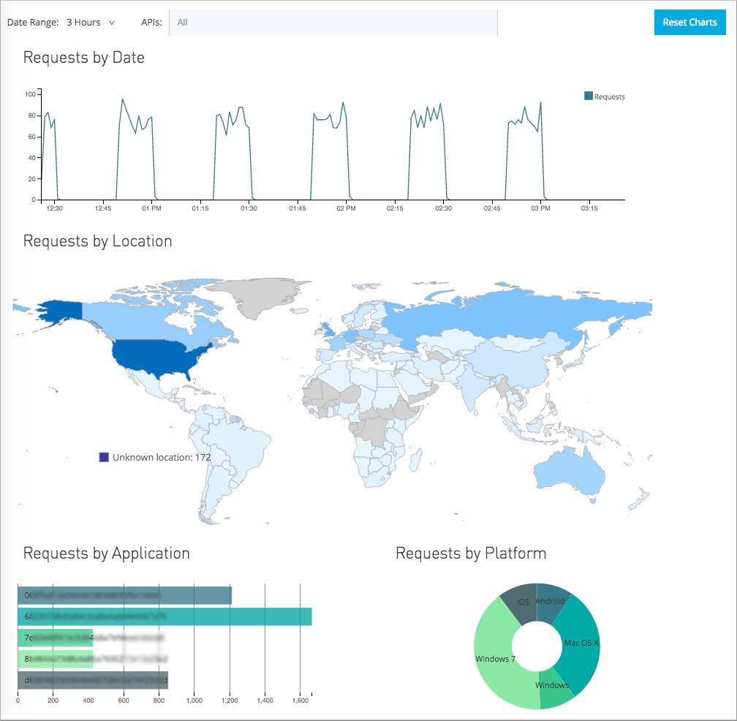

By default, these charts display the data for APIs in your organization for the past day. You can use the filters at the top left of the page to change the date range or filter to particular APIs. The time ranges reflect your local time zone.

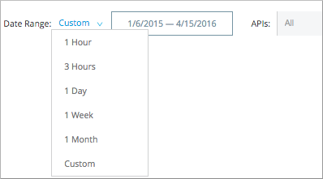

When selecting a custom time interval, the numbers of request of your requests by day line chart are not normalized. For example, monthly chart will show number of requests per 4 hours. For two months, the same chart shows requests per 8 hours. If you are using a line chart in a custom dashboard and need to define a custom interval, you need to explicitly set an aggregation interval.

All of the charts on the Overview Dashboard are cross-filtered. If you filter the data on any one of these charts, the same filter is applied to the other charts on the page. Clicking an individual application in the bar chart, for example, displays all of the requests from that application and the locations for those requests on the map. Here’s how to filter data on individual charts.

Chart | How to filter data | How to clear your filter
Requests by Date | Click and drag an area of the chart to filter to just that time period. Once you have the slider filter applied, you can drag the ends to the left or right to adjust them as needed. | Click outside the area of the filtered portion.
Requests by Location | Click one or more countries to filter to just those results. Hover over a country for a tooltip displaying the name of the country and the total number of API requests received from that country for the selected time period. | Click the country or countries again to reset the map.
Requests by Application | Click one or more application bars to filter to just those results. Hover over an application’s data bar for a tooltip displaying the name of the application and the total number of requests from that application for that time period. | Click the application(s) again to reset the chart.
Requests by Platform | Click one or more segments to filter to just those results. Hover over a segment for a tooltip displaying the name of the application and the total number of requests from that application for that time period. | Click the segment(s) again to reset the chart.

To export the data for any of these charts, click Export export.

If you have filtered data on one of the charts to show only selected data, the export icon triggers an export of a .csv file of the full data for that chart, filtered by whatever date range and API selection you have made using the filters in the upper left of the page. Exported files are limited to a maximum of 1 million records.

Including Policy Violations on the Dashboard

Note: Users must have the View Policies permission set to view policies or edit a Policy Violation alert. For more information, see Setting permissions.

Enable or disable the tracking of policy violations by checking the Include Policy Violations checkbox on the dashboard. The dashboard will show traffic rejected, or not rejected, by a policy.

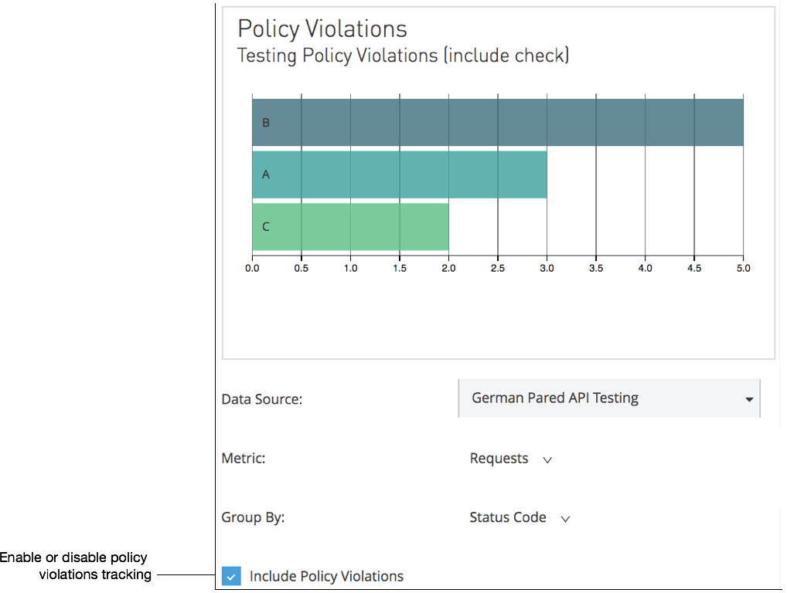

Creating Custom Charts

You can create a wide variety of custom charts to display specific data on your custom dashboard.

For example, you can create custom charts that show:

- Hourly transactions per second between first day of the month and today, filtered by client ID, API version, or SLA tier.
- Per minute latency average in the last 24 hours, filtered by API or grouped by client geolocation.
- Number of policy violations grouped per subscribed application, per violated policy name.

Only charts that group by Violated Policy Name include events that triggered a policy violation. All other charts exclude these events. For example, an API gets 100 requests, 90 succeed, and 10 are rejected by the rate-limiting policy. Charts that do not group by Violated Policy Name compute aggregates based on only the 90 requests that were not rate limited. Charts that group by Violated Policy Name, however, include all 100 requests in their computations.

To create a custom chart, click Manage Charts:

1. In API Manager > Analytics > Manage Charts, click New.

Create Chart appears.
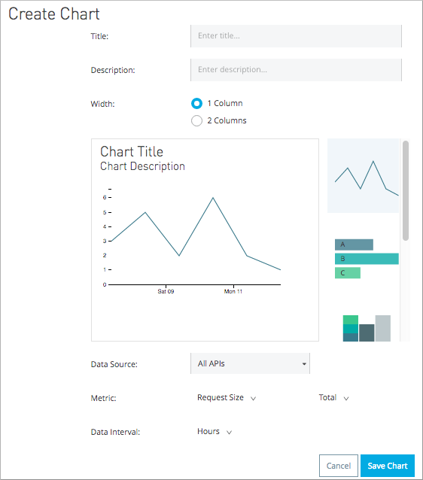

2. Fill in a Title, and, optionally, a Description.

3. Click a chart type graphic:

Icon | Chart Type | Chart Options
 | Line chart | Data Source, Metric: metrics and Total, Data Interval: durations
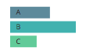 | Bar chart | Data Source, Metric: metrics and Total, Group By: categories
 | Stack chart | Data Source, Metric: metrics and Total, Group By: categories, Then By: categories
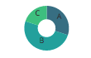 | Ring chart | Data Source, Metric: metrics and Total, Group By: categories
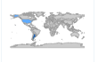 | Map chart | Data Source, Metric: metrics and Total

4. Select a Data Source value:
- All APIs in your organization
- A specific API

5. Select from one of the Metrics metrics value and a Total:
- Request Size (in bytes)
- Requests
- Response Size (in bytes)
- Response Time (in milliseconds)

6. For a Line Chart, select a Data Interval durations value:
- Minutes
- Hours
- Days

7. For a Bar Chart or Stack Chart, select a category for Group By, and if your chart supports it, a category for Then By:
- API Name

- API Version

- Application

- Browser

- City

- Client IP

- Continent

- Country

- Hardware Platform

- OS Family

- OS Major Version

- OS Minor Version

- OS Version

- Postal Code

- Resource Path

- Status Code

- Timezone

- User Agent Type

- User Agent Version

- Verb

- Violated Policy Name
For Stack chart, you can group your data in two different dimensions. The first defines the distinct columns, the second defines the stacks within these columns. The same options are available on the second grouping dimension as on the first.

8. Save the chart.
The custom chart appears.

Example Custom Chart: Policy Violations Per Application

1. In API Manager > Analytics > Manage Charts, click New.
2. In Title, type Policy Violations Per Application.
3. In Description, type Number of violations per subscribed application
4. Select a stack chart.
5. In Data Source and Metric, accept the default values.
6. Select two levels of grouping for the stack chart:
- Select Application to display each application in a different column.
- Select Violated Policy Name as the stack within each column.

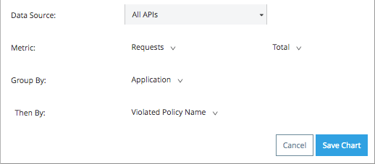
7. Save the chart.
The chart appears:

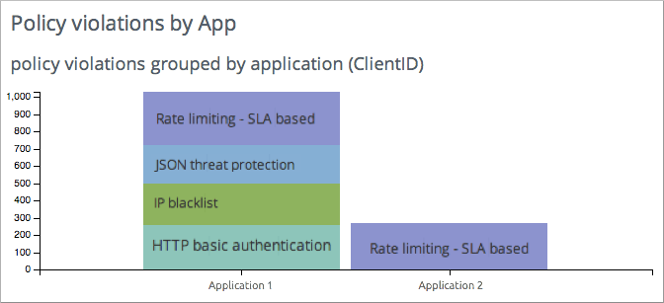

Creating a Custom Dashboard

After you create custom charts, you can display them side by side on a custom dashboard that is unique to you.

To access your custom dashboard, click the Custom Dashboard. The first time you open your custom dashboard, it is blank.

1. In API Manager > Analytics > Custom Dashboard, click Edit Dashboard.

2. Assuming you created custom charts, drag and drop charts from the drawer on the left of the screen onto your dashboard, rearranging them as needed into the order that you want.

3. After you add a chart to your dashboard, you have the option to open it for editing or click the X to remove it from your dashboard.

4. When you are satisfied with your custom dashboard, save it.
The custom dashboard appears.

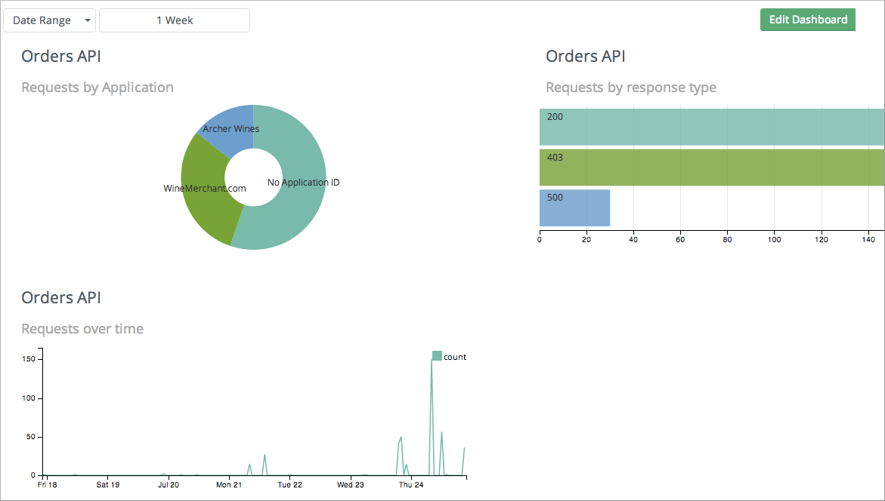
Use the date range picker to adjust the time period for all the charts on your dashboard.

Reviewing Analytics Event Forwarding

Sometimes you need to forward the Anypoint API Analytics events to a third-party system. An example of this could be integrating with ELK or other analytics system.

There are three ways to export events:
- Use the API Analytics Report API to pull the data. One consideration with this method is that the API has limit on the number and frequency of events that can be reported. Additionally, events may have delays of up to 10 minutes from the time the event is generated to the moment it is available for query.
- Forward API Analytics events from the Gateway to configured HTTP endpoint. To configure this on CloudHub, configure the anypoint.platform.analytics_base_uri gateway property from the Settings tab of Runtime Manager.
Setting this property configures the base URL where the events are posted.

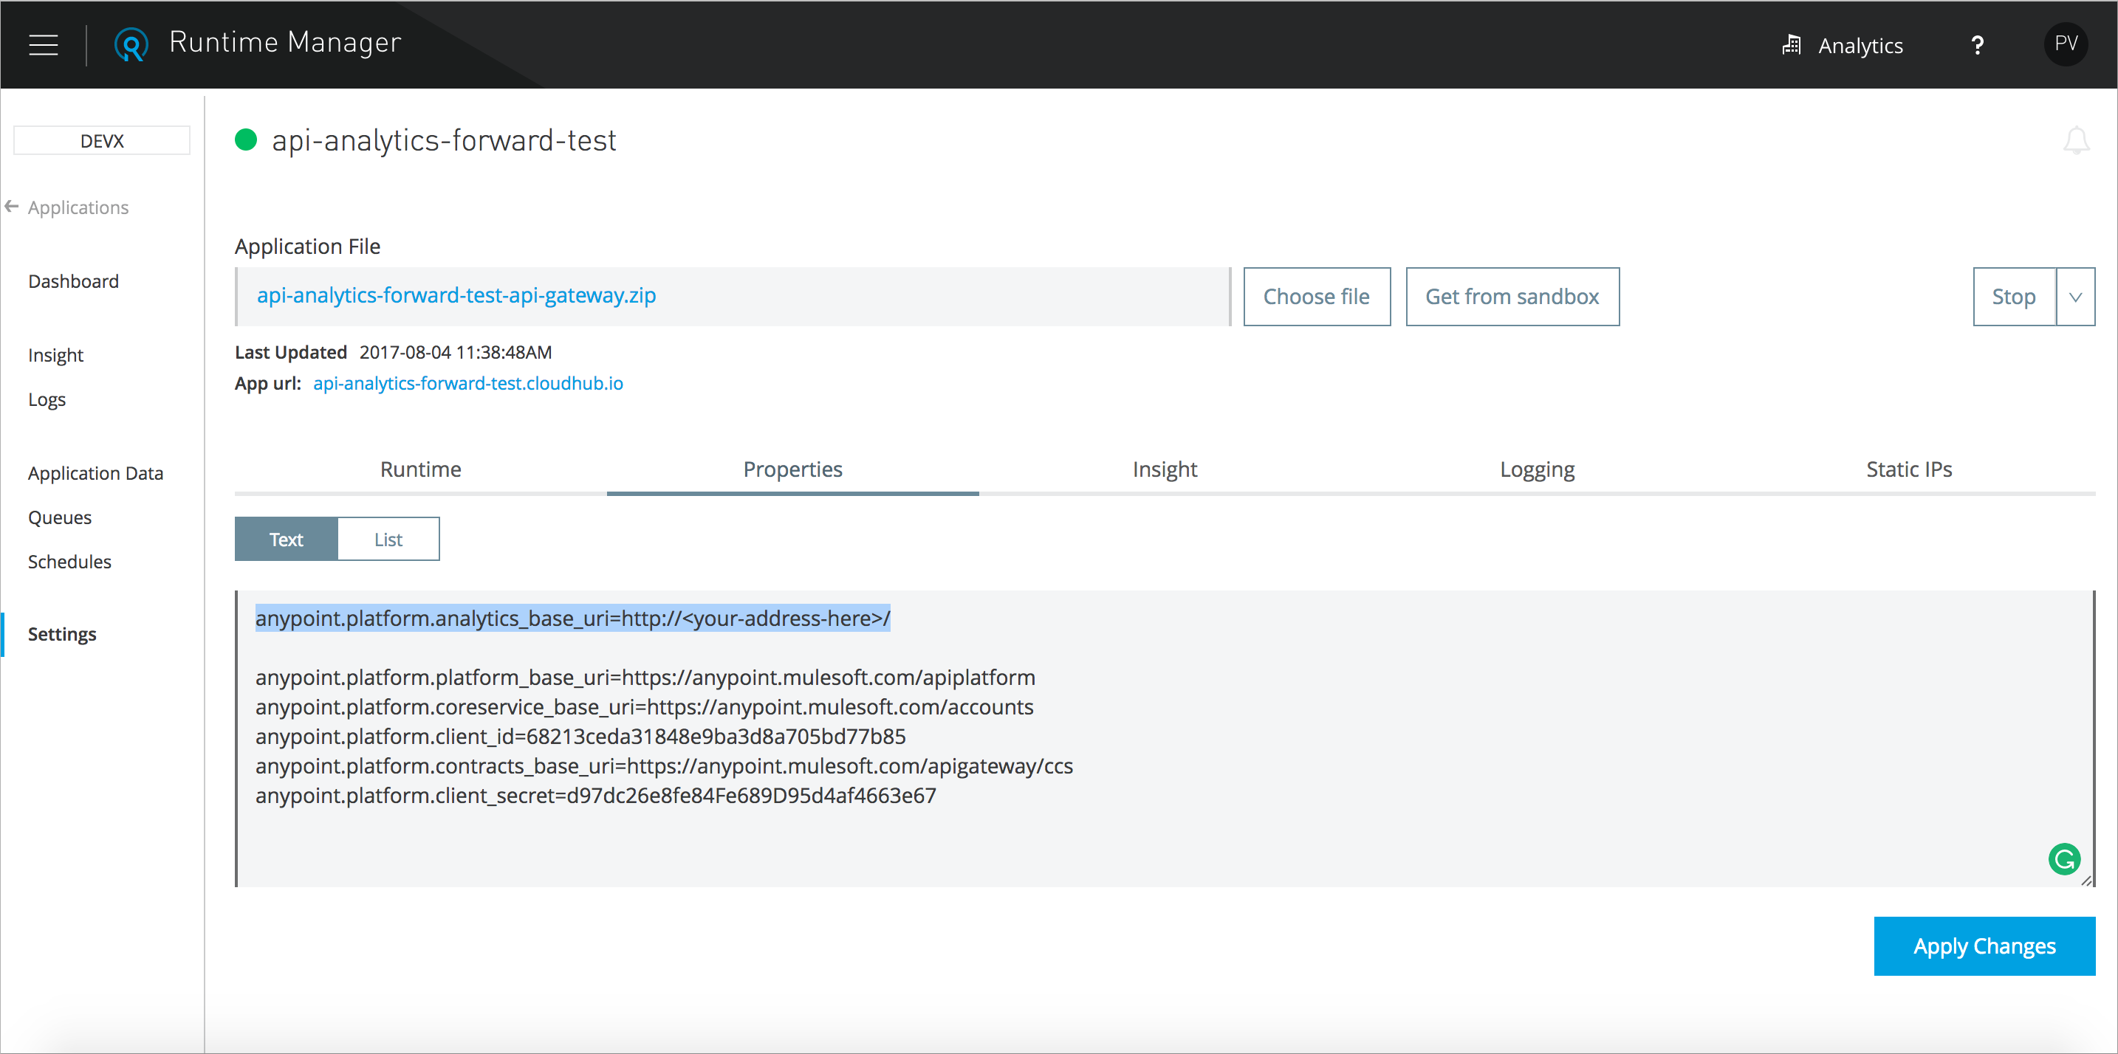

In the example shown above, the events are published to http://<your-address-here>/v2/analytics/events using the POST method and GZIP for compression.

The disadvantage of this approach is that events are not published to Anypoint Platform and neither API Analytics nor API Manager display information about API calls.

Reviewing Analytics Event API

API Manager gathers analytics data for each API you manage. You can create charts that query and display event data. Using the Analytics Event API you can create reports that query raw event data and expose it through an API endpoint. Reports and charts you create present data by environment.

You can create reports that span multiple APIs, or create different reports for the same API. The Analytics Event API provides a one month retention policy for events and, with a data availability delay of up to 10 minutes.

The Analytics Event API enforces a usage limit of 10 requests/minute, with a maximum of 20,000 events per request. Request rates higher than 10 request/minutes will be throttled.

Limitations

1. Event API is designed to create ad hoc reports, and it is not intended as a data export tool. If you need to export data, keep in mind the following recommendations:

- Do not allow calls to overlap time intervals.
- Retrieve all the data that you need in a single request. Do not repeat the same request for every API that you have.
- Do not call Event API more than once per minute.
- For organizations whose API usage exceed 20 000 calls per 10 minutes, consider a different way for data export. API gateway can be configured to send usage events directly to monitoring systems.

2. Event API is not meant for data synchronization.
If you are interested in data sync for events with an external system, refer to Analytics Event Forwarding for more information.
Creating a Report

The following procedure describes how to create a report to find the API events that, for example, resulted in a policy violation. Suppose you want to find any events that were rejected because of policy violations, such as rate limiting or IP blacklisting. In step 5, you select Violated Policy Name in Fields to filter the data in this manner.

- In API Manager > Analytics > Manage Reports, click New to create a new report.
- In Create Report, select a data source, range, and format.
- In Fields, select Violated Policy Name.
A URL appears that you can use to see the report after you save it. The date that data becomes available for the data source you specified appears.
- Save the report.
When the report becomes available, go to the URL to view it.

Running a Report in the Browser

The following steps show you how to run a report. API Analytics lists the starting point for when data is available for the API, including a warning message if no data is available for the API.

On the Manage Reports page, click Run for the specified report.

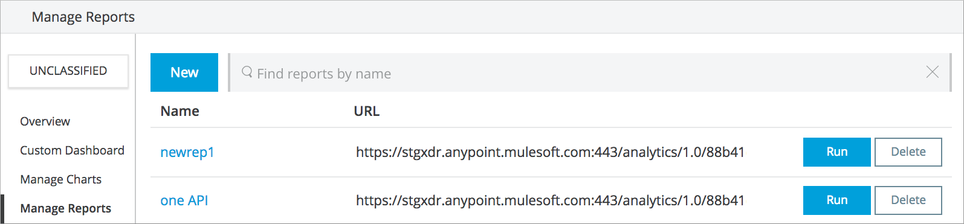
After the report runs, the CSV or JSON file contains all of the raw analytics data for the parameters you specified in the report.

Supporting Environments

For organizations that have enabled environments, API events queried using the approach described above will belong exclusively to the Unclassified" environment. To request events for APIs in a specific environment, select the environment in the environment selector and create the report that you want to run. Reports are stored per-environment, so different reports will exist in different environments. Copy the report URL from the UI, and note that in addition to the Organization ID, the URL also includes /environment/{Environment ID}. Anypoint Platform assigns the unique and immutable Organization ID and Environment IDs at organization and environment creation times.

The addition of the Environment ID to the report URL is all you need to access events in the specified environment. API IDs are different in different environments: An API’s ID in QA will be different from its ID in Production, for example.

